**CMSC 203**

**Fall 2015**

**Assignment #1**

The problem is to calculate the monthly payment amount for a loan, given the starting amount of the loan, interest rate, and number of payments desired. Get the input from the user. Display results on the screen.

**Algorithm/Pseudocode**

Display: title of application: “Loan Calculator”

Display: “Please enter the loan amount you want calculated: ”

Input: loan amount

While the loan amount is less than or equal to 0, then display “You must enter a loan amount greater than 0. Please try again:”

Store the value in a variable called loanAmount

Display: “Please enter the interest rate: ”

Input: interest rate

While the interest rate is less than or equal to 0, then display “You must enter an interest rate greater than 0. Please try again:”

Store the value in a variable called interestRate

Display: “Please enter the number of payments you would like: ”

Input: number of payments

While the number of payments is less than or equal to 0, then display: “The number of payments must be greater than 0. Please try again:”

Store the value in a variable called nPayments

Calculate the monthly payment amount:

The payment = loan amount * ((interestRate/12.0) / (1-(1+(interestRates/12.0))^-numberOfPayments)))

$$payment=loanAmount*\left(\frac{\left(\frac{interestRate}{12.0}\right)}{\left(1-{\left(1+\frac{interestRate}{12.0}\right)}^{-numberOfPayments}\right)}\right)$$

Store the calculation in a variable called payment

Display the monthly payment amount that is calculated.

**Classes:**

class File1

//description: Calculates the monthly loan re-payment amount for the user, depending on the starting amount of the loan, interest rate, and number of payments desired

//Input comes from the user. Results displayed on the screen.

{

**double** loanAmount;

**double** interestRate;

**double** nPayments;

**double** payment;

**final** **double** NUM_MONTHS_IN_YEAR = 12;

}

**Method Documentation:**

No extra methods were created. The program was all written under the main method.

void main(String [] args)

//precondition : none

//postcondition: loan amount, interest rate, and number of payments will be > 0. Monthly payment amount is calculated and stored and returned to client.

//description:

// 1. Ask user for starting loan amount, validate input

// 2. Ask user for interest rate, validate input

// 3. Ask user for number of payments desired, validate input

//4. Calculate payments, and print out the result

**Test table:**

|  |  |  |  |  |  |
| --- | --- | --- | --- | --- | --- |
| Test  Number | Input Variable Values | | | Expected Results (manually calculated) | Actual Results (from running the program) |
| Loan  Amount | APR | Number of Payments |
| 1 | $20,000 | 4.5 | 180 | $152.99865776269034 | $152.99865776269263 |
| 2 | $15,375 | 3.2 | 144 | $128.72018471770019 | $128.720184717703 |
| 3 | $1,000 | 1.0 | 1 | $1000.833333333333 | $1000.8333333334407 |
| 4 | $6,500 | 0 | ---> | “You must enter an interest rate greater than 0. Please try again: ” | “You must enter an interest rate greater than 0. Please try again: ” |
| 5 | $10,000 | 1.0 | 12 | $837.854115557969 | $837.854115558062 |
| 6 | $-20,000 | ---> | ---> | “You must enter a loan amount greater than 0. Please try again: ” | “You must enter a loan amount greater than 0. Please try again: ” |
| 7 | $1,250 | 6.8 | -12 | “The number of payments must be greater than 0. Please try again: ” | “The number of payments must be greater than 0. Please try again:” |

**Screenshots:**

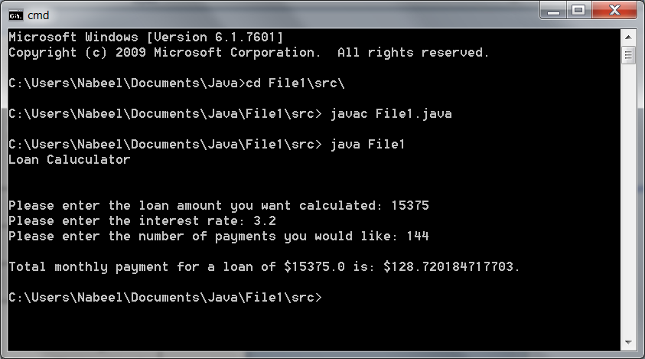

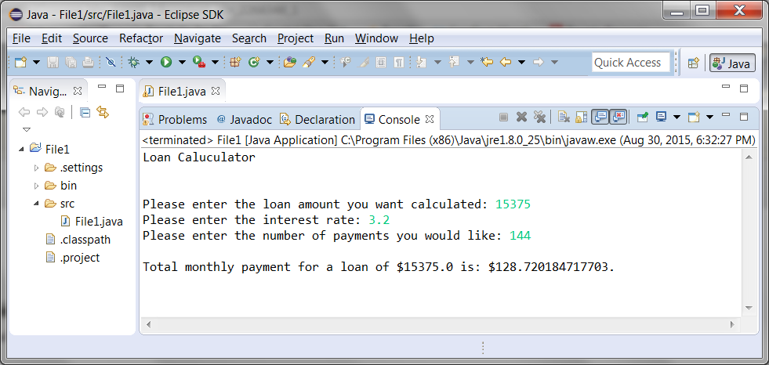

**Assumptions (if any)**

1. Loan amount, interest rate, and number of payments must all be greater than 0. If not, then monthly payment cannot be calculated.

2. Loan amount, interest rate, and number of payments will be type Double.

**Lessons Learned:**

**In 3+ paragraphs, highlight your lessons learned and learning experience from working on this project. How did you do? What have you learned? What did you struggle with? How will you approach your next project differently?**

Overall, I found this first project fairly straightforward, in terms of writing the program, as it brought back many of the fundamental concepts I learned in the C++ class I took over the summer. There are many similarities in C++ and Java, and it did not take me much time to figure out the differences in syntax between the two languages.

I feel like I did very well on this project, and nothing seemed to be too confusing for me, as it felt more like a review than anything else. I learned the different syntax in Java, such as using System.out.print() to display text, and making sure to add the Scanner class in my programs to allow input in my code.

What I found a little challenging and time consuming was setting up the Java JDK, and making sure it was connected to the right directory in my computer, for it to properly compile and run the code. After watching the video tutorials that were attached in the Module 1 a couple times, and some videos on YouTube, I finally understood how to do it and got it to work.

I felt like I managed my time pretty well, and got started on everything early, so I did not have to rush anything before the deadline. There were not too many things that were overly challenging in this module, and the things I had some questions on, I was able to figure it out on my own.